SMART BILLING SYSTEM FOR WATER SUPPLIERS

# MIND CRACKERS

### LOVESON PAUL

### HELAN SELVIN

INTRODUCTION

In day-to-days life, the water is supplied by the Municipal Corporation which should be in proper manner so that there should be minimum loss of water. The basic idea behind this system is to use the available resource of water efficiently. In this system the customer will first pay for the water and then he will get the benefit of that prepaid amount. The systems which are used previously have many drawbacks such as more or less billing amount, loss of water, etc. Sometimes the complaints of people have been received by the Municipal Corporation.

PROPOSED SYSTEM

The prepaid system can be made for the water as well for gas and electricity. This could be achieved by the use of suitable processor and the interface to that processor. The RFID based smart card has been used for the storage of the prepaid data which is secure [1] - [2]. In another system, the water system is implemented in such a way that the generated bill amount will be sent to the administrative office.

The datas of the customers have been saved in the cloudant database.Whenever the the card is swiped the value is passed through cloud and the value can be retrieved from the cloud for the web app.Whenever the card is swipped it shows whether he can access water or not based on the balance in his card.When the ID of the card is entered in the web app the values are retrieved from the cloud and the details can be seen in the web app.

PROJECT HIGHLIGHTS

* RFID Technology.
* Integrating RFID module with Node MCU
* Reading the data from the RFID cards
* Sending HTTP Request to Cloud Platform
* Creating Web Application with different logins and money wallets for payment

HARDWARE

* ESP8266-12E module(Node MCU)
* RFID Reader and Cards
* OLED display
* Basic board

SOFTWARE

* Arduino IDE
* Node Red
* IBM Cloud platform
* Cloudant Database

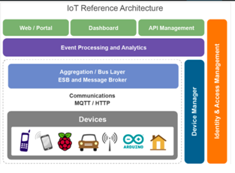

RFID TECHNOLOGY

RFID (Radio-Frequency Identification) technology is in mobile phones, credit cards, pet tracking chips, toll booths, and in tags for just about everything sold these days. Like many technologies used in consumer-end devices, RFID began as a military application.

There are two distinctly different types of RFID technology: passive and active.

A passive RFID system has an antenna and circuitry that houses a unique code, but has no power source. A passive RFID system requires a reader to induce current into the RFID tag’s circuitry, similar to how the German planes required radar to bounce off of them.

There are a variety of ranges and frequencies used for passive RFID, but the most common are:

* Low frequency: ~125 kHz. Typically has a range of a few centimeters
* High frequency: 13.56 MHz. Has a range of up to a meter
* Ultra-high frequency: ~865 MHz. Has a range of about 30 meters

Passive RFID has a very short range, but they are still very popular because they are inexpensive and they last a long time without service.

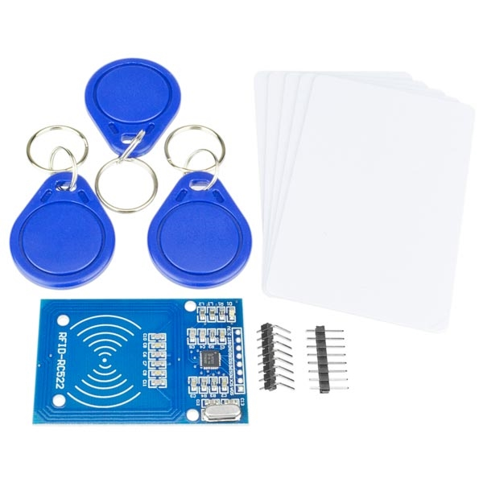

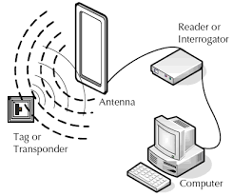

**Active RFID**

Like the IFF transmitters on British fighter planes, active RFID systems require power to transmit their code. Active RFID systems have a much longer range than passive systems, some up to a few hundred meters. Active RFID usually operates at 433 MHz or 915 MHz.

Algorithm for the prepaid system:

1. Insert the smart card in the smart card slot.

2. Read the value on smart card.

3. Turn on the water supply with the help of servo motor.

4. When the units on smart card reaches below 500, turn off water supply .

ADVANTAGES

Improved Customer Engagement

• Technology Optimization

• Reduced Waste

• Enhanced Data Collection

DISADVANTAGES

Security

• Privacy

• Complexity

• Flexibility

• Compliance

CONCLUSION

The system designed in this project can be implemented and used easily. As the system is user friendly it can be applicable for electricity and gas. In this paper the system has been used for one application. Further in future development the system can be implemented for more than one application such as electricity and gas supply in one smart card. Then the user can increase credit either on electricity, water or gas with the single smart card. The user can avoid the trouble for paying different bills every month and can save lot of time. Thus the system designed will be convenient for the users to plan their monthly expenses since the electricity; water and gas bills are already paid before using.